# ODE Modeling Exercises

## Exercise 3: ODE Modeling. Single reaction model - Template for answers

To submit your homework, please provide a similar .doc as this, where you describe the results you get for the Exercise 3.

**ODE Modeling basics:**

1. What are the two main assumptions made in kinetic modeling of metabolic reactions with Ordinary Differential Equations (ODEs)?

Answer: list the main assumptions here

1. Write formulas for two elementary reactions (production and degradation) using ODEs.

Answer: provide the ODEs for production and degradation of one species

**Learning to build ODE models through a simple substrate-product reaction system.**

Consider the following simple enzymatic reaction mechanism

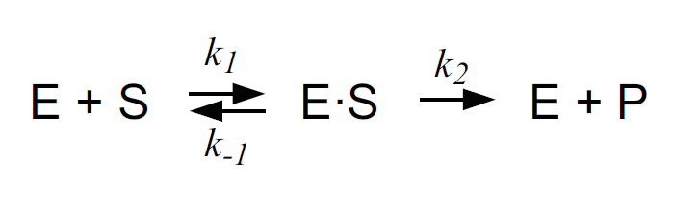

3) Enzyme Kinetics: Mass Action Law vs. Approximation (Michaelis – Menten Law). The above described artificial system includes four species / state variables (E, S, ES, P).

1. What are the two assumptions and two simplifications that were made to derive an analytical solution for the Michaelis Menten approximation?

Answer: list the assumptions and simplifications

1. In the script “EnzymeKineticsMassAction.m”, this system is already defined assuming mass action kinetics for the three reactions. Run this script to simulate the change in concentrations of the four species over time.
   1. In the provided MATLAB code, find the values of the reaction rate constants k1, k-1, k2.  
      Answer: write the values for k1, k-1, k2
   2. The simulated results are stored in the struct “simData” which is generated when you simulate the ODE model. Plot the results for all species (E, S, ES, P).  
      Answer: insert the plot here
   3. In the plot, identify (approximately) the pre-steady state regime and the quasi steady state regimes. Does the total enzyme in the system change?   
      Answer: write your estimate of pre-steady and quasi steady state regimes, answer the question about total enzyme.
2. Using the Michaelis Menten definition, calculate the Km value of the enzyme E.   
   *Hint: Use the k1, k-1, k2 values you identified.*

Answer: write the Km value

1. In the script “EnzymeKineticsMM.m”, the reaction from S to P is defined using the Michaelis-Menten kinetics. In a for loop, the initial velocity (v0) of this reaction is calculated for different initial concentrations of the substrate S (from 1 to 600). Run this script to simulate the system and create the vector of v0.
2. Plot reaction rates (v0) vs. substrate concentrations ([S]). From the plot, estimate the Vmax and Km values.

Answer: insert the plot and write down the estimated Vmax and Km values.

1. Increase the “InitialAmount” of the species “E” by 10 units. Run the script, plot the v0 vs. S and estimate again the Vmax and the Km values of the system. What do you observe?

Answer

**Pen and Paper exercise: Michaelis Menten kinetics with competitive inhibition**

Consider the following enzymatic reaction mechanism:

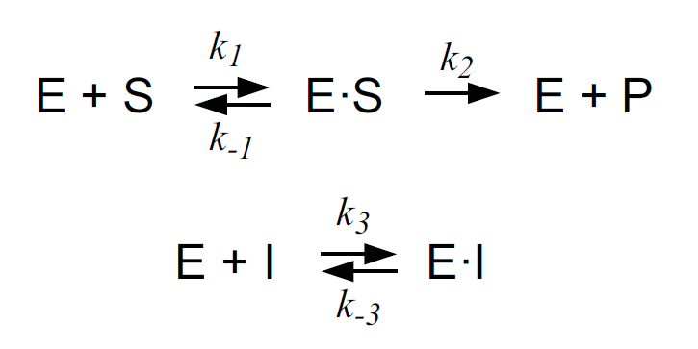

4) Write the Balance Equations for the species’ concentrations of the above reactions under the assumption of mass-action kinetics.

5) Derive the reaction rate expression ($v$) for competitive inhibition, given the following assumptions:

* Quasi Steady State assumption for intermediate complexes ES and EI: $\frac{d[ES]}{dt}=0,\frac{d[EI]}{dt}=0$
* Conservation of Enzyme $(E$) species: $E_{T}=E+ES+EI$

$\frac{d[P]}{dt}=reaction rate=v$

*Hint*: The final formula of the rate law should look like: $\frac{d[P]}{dt}=v=\frac{V_{max}*[S]}{\left[S\right]+ K_{m}(1+\frac{[I]}{K_{I}})}, \left[S\right]≅[S_{0}]$  
Answer: you do not need to type your solution here. It is VERY important that you make sure you are able to solve both 4) and 5) parts of the exercise.

**Understanding the effect of competitive inhibition in reaction rates with an ODE model**

6) Implement and simulate an ODE model describing the above reaction (with competitive inhibition). Name you script “EnzymeKineticsMMwCompInhib.m”. Make use of the MM rate law for competitive inhibition that you derived. Use the same values for the parameters Kcat, Km as in the simple MM model. Do the same for the InitialAmount values of species S and E (use **1 unit** as initial value for species E).

*KI = 6 units, InitialAmount of Inhibitor (I) = 10* *units*

1. Does Vmax change, and if yes what is the new value?

Answer

1. Does the apparent Km change and if yes what is the new value?

Answer